PART –B: ACADEMICS

(XIV). RESULTS

CBSE RESULTS 2019

CLASS X : Appeared : 280 Passed : 280

CLASS XII : Appeared :194 Passed :194

1(a) Result of School/Board Examination during the last 3 years:

S.No. | Class | Session | Pass  Percentage | Performance  Index
1 | X | 1.2019 | 100 | 77.21
 |  | 2.2018 | 100 | 73.3
 |  | 3.2017 | 100 | 81.68
2 | XII | 1.2019 | 100 | 75.14
 |  | 2.2018 | 100 | 77.7
 |  | 3.2017 | 99.5 | 75.9

(b) Any outstanding achievement of students in the Board Examination.

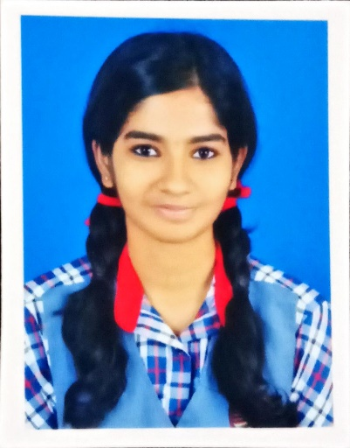

KUM. VARSHA VIJAY

99.2%

COMMERCE STREAM

KERALA TOPPER IN AISSCE EXAM

THIRD TOPPER OF KVS AT ALL INDIA LEVEL

100 IN ECONOMICS, BUSINESS STUDIES & IP

SCIENCE STREAM TOPPERS MARCH 2019

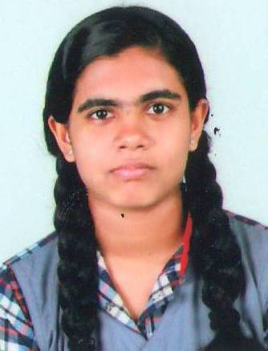 | 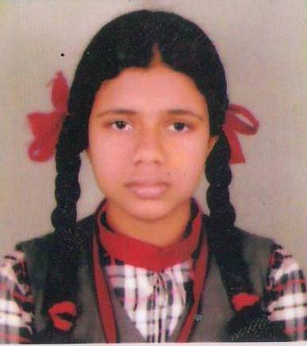
APARNA K | AKSHAYA PADMAKUMAR | HRISHIKA PRASAD C | ANJANEY SUDHAKARAN
96% | 95.2% | 94.8% | 94.8%

COMMERCE STREAM TOPPERS MARCH 2019

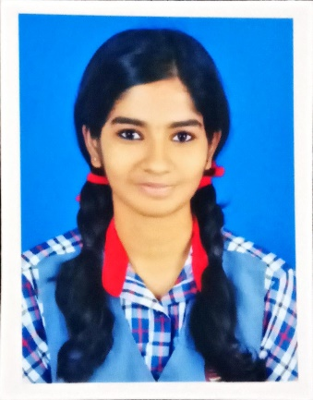 | 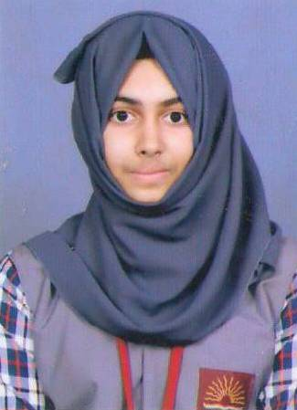 | 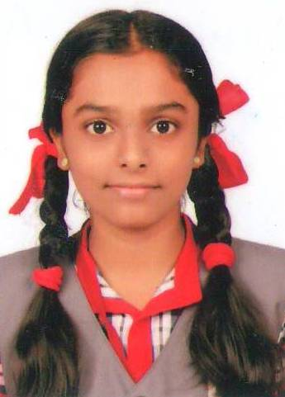
VARSHA VIJAY | FEBINU P | AISWARYA A
99.2%  100/100 IN  ECO/BS/IP | 96% | 95.6%

HUMANITIES STREAM TOPPERS MARCH 2019

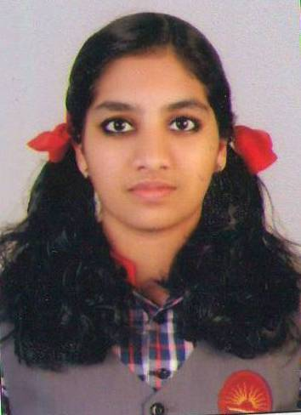 | 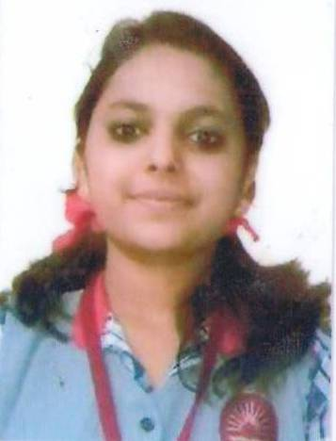
ALEENA SANTHOSH | PUNNYA GOPI | ATHEENA K
97.4 %  100/100 IN HISTORY | 97% | 96%

TOPPERS IN CLASS X

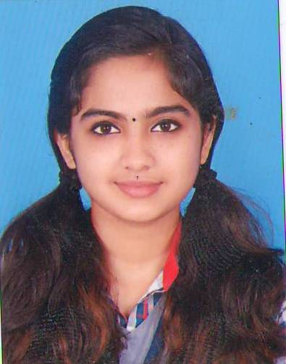
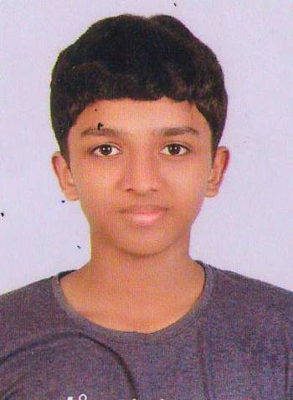

SREELAKSHMI N K ABHINAV K B DEVIKA S ARYAN RANJITH
97.4 % 97.2 % 97.2 % 97%

